Week2 Day1 page

Josh page they used sub-grids

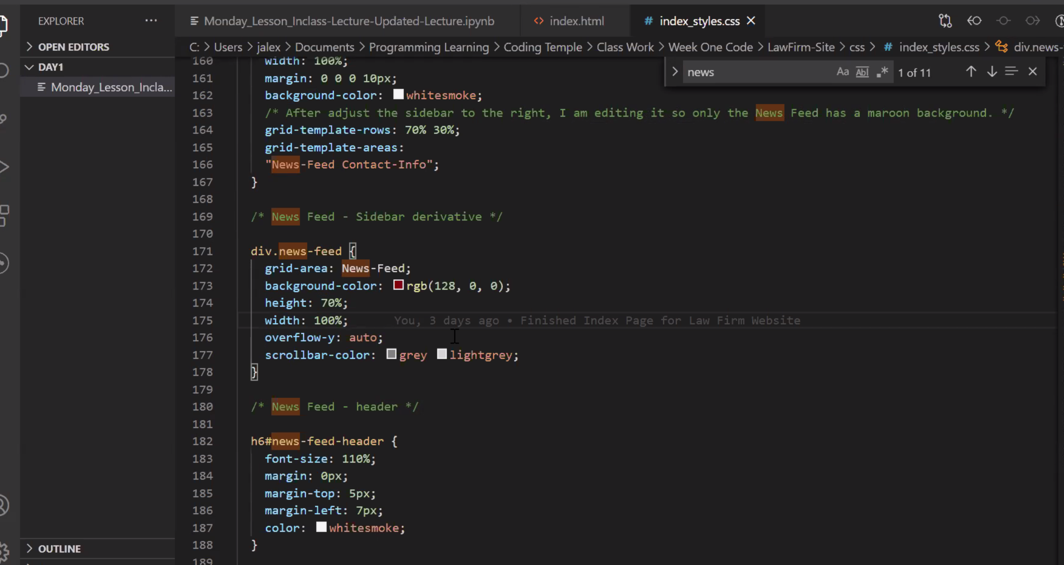

Mikes page

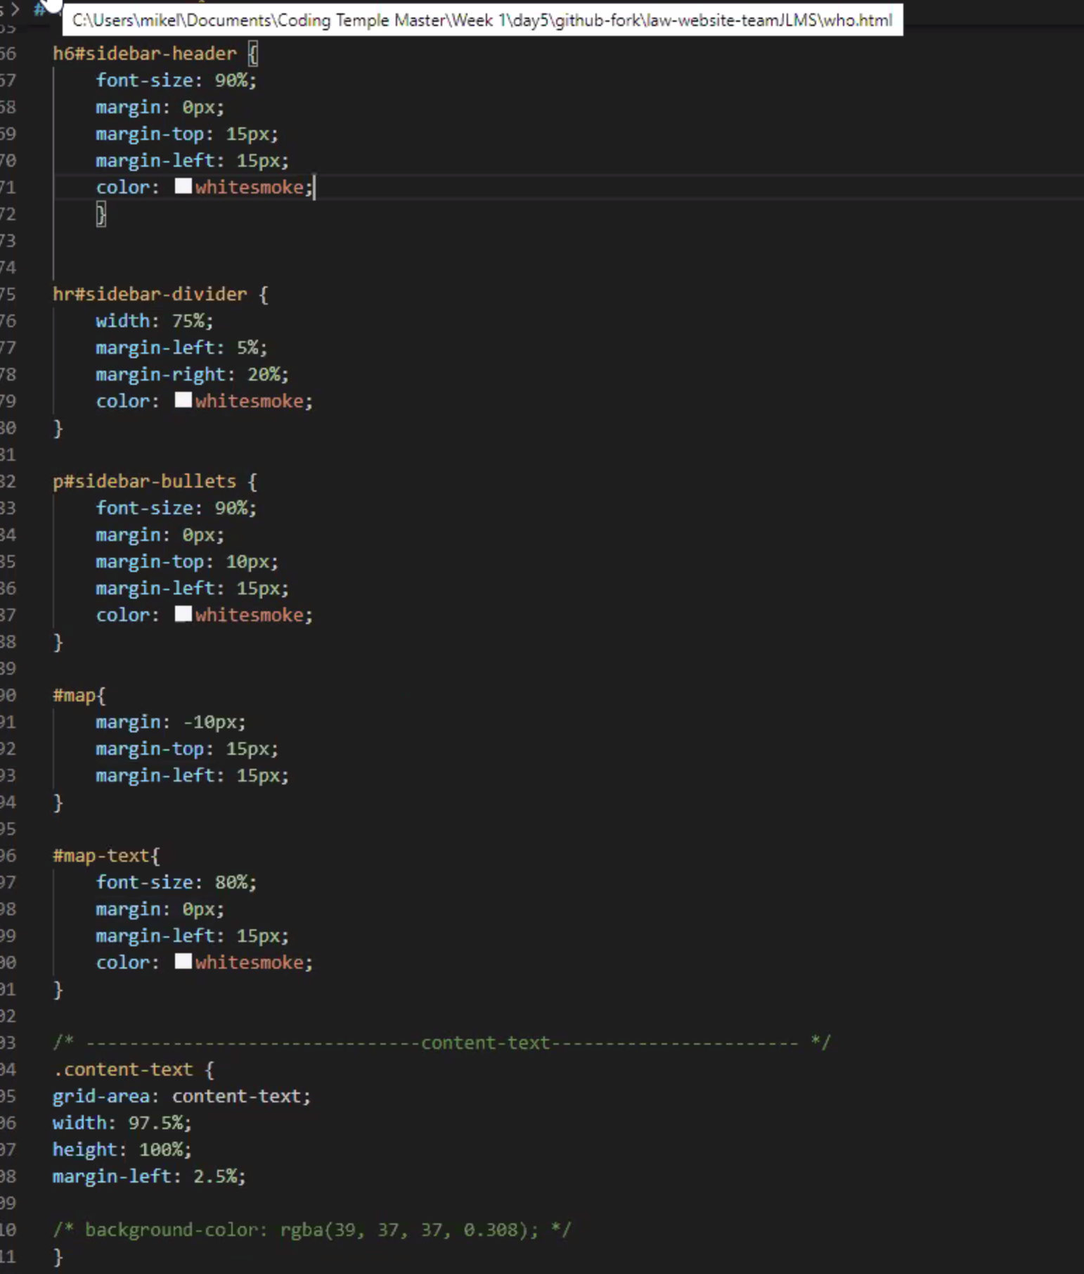

Leyland

